Project Design Phase-II
Technology Stack (Architecture & Stack)

Date | 27 june 2025
Team ID | LTVIP2025TMID59882
Project Name | TrafficTelligence: Advanced Traffic Volume Estimation with Machine Learning
Maximum Marks | 4 Marks

Technical Architecture:
The Deliverable shall include the architectural diagram as below and the information as per the table1 & table 2
Reference: https://developer.ibm.com/patterns/ai-powered-backend-system-for-order-processing-during-pandemics/

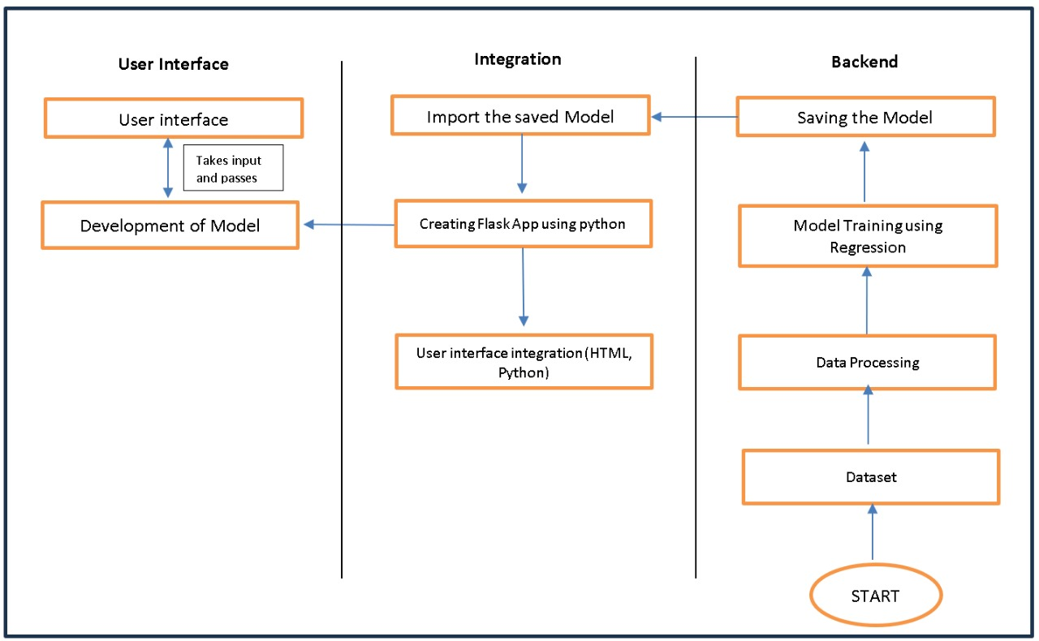

Table-1: Components & Technologies:
S.No | Component | Description | Technology
 | User Interface | Critical element designed for both Traffic Managers and everyday users, ensuring an intuitive and informative experience. | HTML, CSS, JavaScript
 | Application Logic | Involves a robust backend system responsible for processing, analyzing, and managing traffic data. | Python
 | Database | Involves the storage and management of diverse traffic data for analysis. | File Manager, csv
 | File Storage | Involves managing diverse types of data, including raw traffic data, machine learning models, and configuration files. | Local System, Google Drive
 | Frame Work | It is a crucial part of our program as it is responsible for connecting the frontend with the backend. | Python Flask
 | Machine Learning Model | The machine learning model is responsible for predicting future outcomes based on available data. | Machine learning model created using regression algorithms
 | Infrastructure (Server / Cloud) | Involves a combination of servers and cloud services to support the computational and storage needs of the application. | Local

Table-2: Application Characteristics:
S.No | Characteristics | Description | Technology
 | Open-Source Frameworks | Using cameras to collect data and to make models for specific locations. | Python’s Flask
 | Scalability | Immediate classification of produce as healthy or rotten. | Computer vision, dynamic databases.
 | Performance | Regular performance testing, monitoring, and optimization are integral components of the development and maintenance processes, ensuring that TrafficTelligence consistently delivers timely and efficient traffic volume estimations. | R squared, Root mean squared error, Root Mean Square deviation.
 | Availability | Website can be made available all time in a webserver. This makes the website running without any issues. | High speed Linux based webservers.

References:
https://c4model.com/
https://developer.ibm.com/patterns/online-order-processing-system-during-pandemic/
https://www.ibm.com/cloud/architecture
https://aws.amazon.com/architecture
https://medium.com/the-internal-startup/how-to-draw-useful-technical-architecture-diagrams-2d20c9fda90d

